Name: ___________________________ Date: ________________ Period: _________ Seat # ____

Basic Skill: Micropipetting/Centrifugation
(Color Wheel Lab)
Introduction: This laboratory introduces micropipetting technique which is used throughout this course. Mastering of this technique is important for good results in all of the experiments to follow. Most of the laboratories are based on microchemical protocols that use very small volumes of DNA and reagents. These require use of an adjustable micropipettor that measures as little as one microliter (μl) – a millionth of a liter.

Purpose: To accurately manipulate small volumes of fluid using proper micropipetting technique
Part 1 – Using a Microcentrifuge
Using the microcentrifuge:
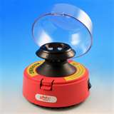
Purpose for centrifugation:
- To separate liquid and solids or substances into different density.
- To collect small droplets of water into one large drop for easy pick up with a pipet.

Questions:
- Why must a centrifuge always be balanced?

- Balancing a microcentrifuge –Using the rotor diagram below, show how you would balance 2 tubes, 3 tubes, 4 tubes, and 5 tubes in the 6-place rotor below.

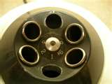

*Challenge*: Using the rotor diagram below to show how you would balance 3 – 8 tubes in 12-place rotor and 3-8 tubes in 16-place rotor (note: you will be using only the top row).
In balancing odd numbers of tubes, begin with a balanced triangle of three tubes, then add balanced pairs. Darken the spaces where you would place a tube. If you cannot balance, mark X on the rotor.
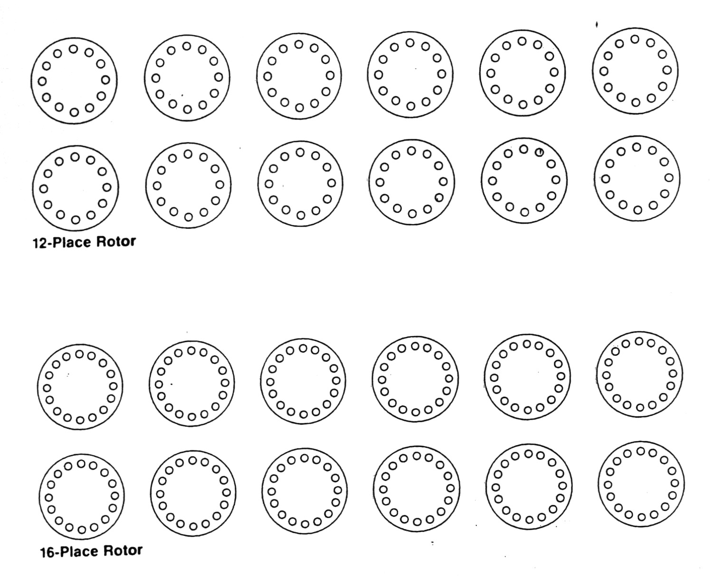

- Describe how you would balance one sample with a volume of 20 μl of fluid.
Part 2 – Measurements (Metric Conversions)
Become familiar with metric units of measurement and their conversions. We will concentrate on liquid measurements based on the liter but the same prefixes also apply to dry measurements based on the gram. The two most useful units of liquid measurement in molecular biology are milliliters (mL) and microliters (μl).

1ml = 0.001 liter 1 μl = 0.000001 liter 1000 ml = 1 liter 1000000 μl = 1 liter

Complete the following conversions:
________ μl = 1 mL; 100 μl = ______ mL; 10 μl = _______ mL ; & 1 μl = _________ mL
Part 3 – Practicing with Small Amounts
First, read the six “Never” Laws of Micropipets at the end of this laboratory handout. Detach it; cut it; then paste them onto an index card and keep them in your laboratory cupboard with your micropipets. Read these instructions very, very carefully!!!

Second, learn the part of the micropipette from the image on the left.
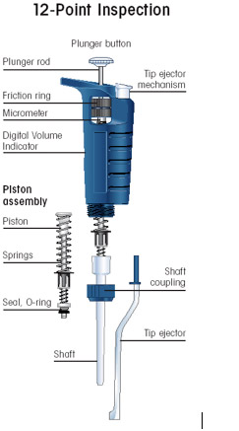
Third, read the pipetting directions below then complete the laboratory activity below.
Pipetting Directions
- Rotate volume adjustor to desired setting. Note change in plunger length as volume is changed.
- Firmly seat proper sized tip on end of micropipettor.
- When withdrawing or expelling fluid, always hold tube firmly between thumb and forefinger. Hold tube at nearly eye level to observe the change in the fluid level in pipet tip. Do not pipet with tube in test tube rack or have another person hold tube while pipetting.
- Each tube must be held in the hand during each manipulation. Grasping the tube body, rather than the lid, provides more control and avoids contamination from the hands.
- Hold pipettor almost vertical when filling.
- Most digital micropipettors have a two-position plunger with friction “stops.” Depression to the first stop measures the desired volume. Depressing to the second stop introduces an additional volume of air to blow out any solution remaining in the tip. Pay attention to these friction stops.

- To withdraw sample from reagent tube:
  - Depress plunger to first stop and hold in this position. Dip tip into solution to be pipetted, and draw fluid into tip by gradually releasing plunger.
  - Slide pipet tip out along inside wall of the reagent tube to dislodge excess droplets adhering to the outside of tip.
  - Check that there is no air space at the very end of the tip. To avoid future pipetting errors, learn to recognize the approximate level that particular volumes fill the pipet tip.

- To expel sample into reaction tube:
  - Touch pipet tip to inside wall of reaction tube into which the sample will be emptied. This creates a capillary effect that helps draw fluid out of tip.
  - Slowly depress plunger to the first stop to expel sample. Depress to second stop to blow out last bit of fluid. Hold plunger in depressed position.
  - Slide pipet out of reaction tube with plunger depressed to avoid sucking any liquid back into tip.
  - Eject the tip into a beaker kept on the lab bench for this purpose. The tip is ejected by depressing a separate tip-ejection button.
- To prevent cross-contamination of reagents:
  - Always add appropriate amounts of single reagent sequentially to all reaction tubes.
  - Release each reagent drop onto new location on inside wall, near bottom of reaction tube. In this way, the same tip can be used to pipet the reagent into each reaction tube.
  - Use fresh tip for each new reagent to be pipetted.
  - If tip becomes contaminated, switch to a new one.
- Eject used tips into a beaker kept on the bench for this purpose.

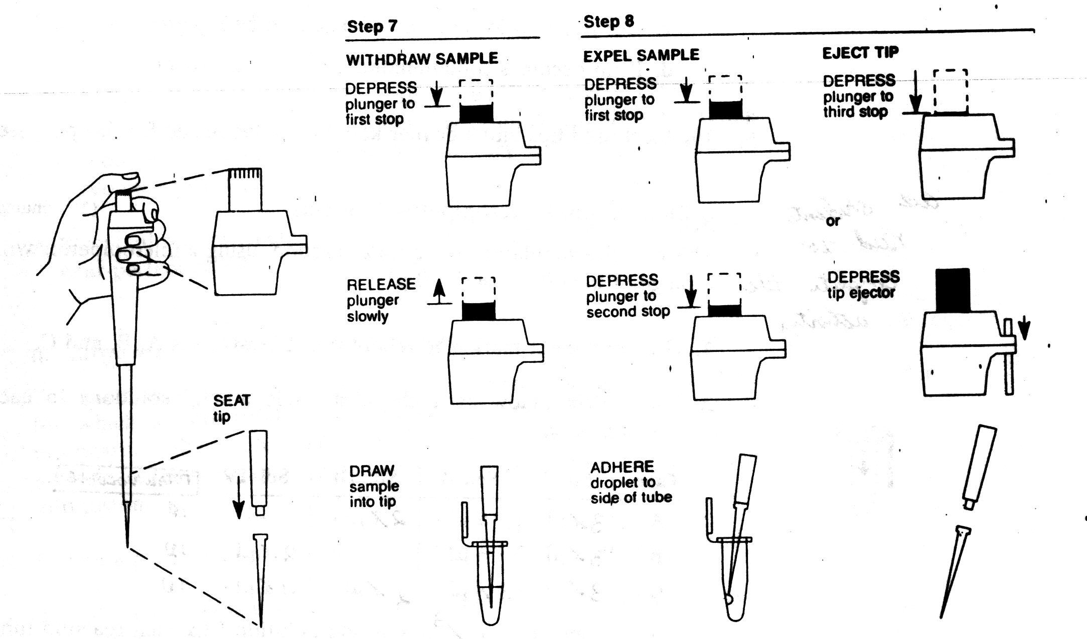
Activity:
Do one of the activities below. When you are done, please have your teacher inspect your product for a signature.

Using a P-20:
- Put 5 μl of water onto a piece of wax paper.
- Add 2 μl of blue solution and carfully watch it mix in with the water. Pipet up and down slowly to mix.
- Add 2 μl of red solution and carfully watch it go into the liquid. Pipet up and down slowly to mix.
- Pick up 2 μl of the mixture and put it into an Eppendorf Tube (centrifuge tube). Tip: Touch the tip to the side of the tube and move the tip away from the side as you release.
- Spin the tube for a few seconds in a balanced centrifuge.
- Label the tube “2 μl” and show to the instructor Instructor signature: _________________
Or

Using a P-200:
- Put a 50 μl of water into an Eppendorf tube.
- Add 20 μl of any color.
- Slowly pipet up and down to mix.
- Add 20 μl of any other color.
- Slowly pipet up and down to mix.
- Show to the instructor Instructor signature: ________________________

Part 4 – Practicing Accuracy
- Pick Either a P-20 or P-200 to work with
- If you are using a P-20, put the following amounts in an Eppendorf tube. Switch tips each time.
Color Amount
Red 0 μl
Yellow 3.4 μl
Green 2.6 μl
Blue 12 μl
OR
- If you are using a P-200, put the following amounts in an Eppendorf tube. Switch tips each time.
Color Amount
Red 28 μl
Yellow 41 μl
Green 0 μl
Blue 37 μl

- Spin the tubes in the balanced microcentrifuge for a few seconds to pool the solutions.
- To check your accuracy, set your pipet to the TOTAL amount.
    - For P-20, set to 18 μl
    - For P-200, set to 106 μl

Slowly attempt to draw all the fluid out of your tube. The contents should just fill the tip --- no air space at the bottom of the tip, no leftover fluid in the tube. Brag to Mrs. Ancheta if you are able to just fill the tip exactly. You are a Pipet Superstar.

Instructor signature: _________________

Part 5 – Explaining Volume Errors
- How accurately were you able to manipulate the small volumes in part 4? Write down some precautions that you should keep in mind as you manipulate your micropipette.

- What common error can account for over-micropipetting?

- What errors can account for under-micropipetting?

Part 6– Micropipet Color Wheel
- Place a 3 μl drops of each of the basic colors (green, blue, red, and yellow) on a piece of filter paper (remember to change tips). Label each drop with the name of the color.
- Each person in your group should make one of the mixture colors in a separate Eppendorf tube and then you can share them.

Colors of mixture Green Blue Red Yellow
Teal 5 μl 15 μl 0 0
Rose 0 5 μl 15 μl 0
Orange 0 0 6 14 μl
Chartreuse 2 μl 0 0 18 μl

- Place the four color mixtures in the microfuge. Remember to balance the microfuge. Give the tube a short (2-second) pulse to mist the dyes into a single drop).
- DROP a 3 μl sample of each of the mixed colors on the same piece of filter paper that has the basic color spots on it. LABEL EACH COLOR!
- Everyone: Attach the filter paper to your lab notebook with a piece of tape.
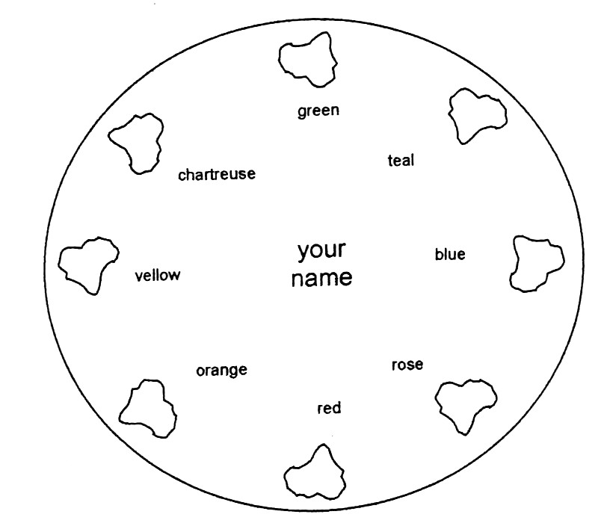
Six “Never” Laws of Micropipets
- Never rotate volume adjustor beyond the upper or lower range of the pipet, as stated by the manufacturer.
- Never use micropipettor without tip in place; this could ruin the precision that measures the volume of fluid.
- Never lay down pipettor with filled tip; fluid could run back into the piston.
- Never let plunger snap back after withdrawing or ejecting fluid; this could damage piston.
- Never immerse barrel of pipettor in fluid.
- Never flame miropipettor tips.

Micropipetting Practical Check List

_____ 1. Select the appropriate pipet for a given volume
_____ 2. Properly set the volume on the pipet.
_____ 3. Securely attach the pipet tip on the pipet.
_____ 4. Push the plunger before withdrawing the liquid to the “first” stop.
_____ 5. Hold the micropipette almost vertically when withdrawing the liquid.
_____ 6. Slowly withdraw the liquid to not introduce air bubbles.
_____ 7. Slowly expel the liquid by pushing the plunger to the second stop.
_____ 8. After expelling the liquid, move the tip away from the liquid with the thumb pressing down on the plunger.
_____ 9. Eject the used tip properly into the waste container.
_____ 10. Follow all “never” laws.

